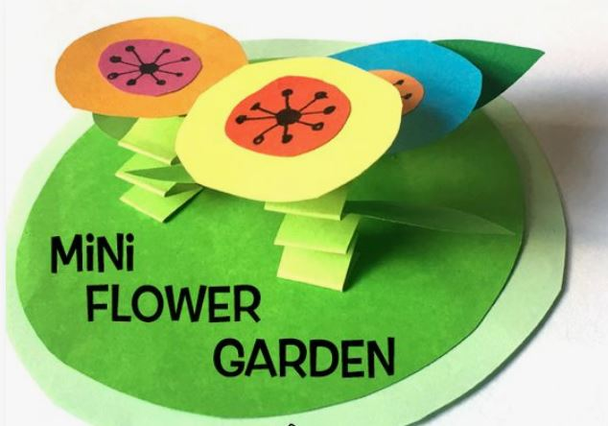

Craft instructions for your Mini Flower Garden

- You will need scissors, glue and coloured markers.
- From the green sheet, cut out the oval for your garden lawn, the 8 leaves and the 8 strips for the stems. To maximise your piece sizes, there is a suggested layout of your green pieces on the back of this sheet.
- To make the 4 flower stems, fold the long green strips together like accordian (2 strips per stem. Your child may remember the technique from the Faltwurm in she/he recieved in the last envelope from GAP; diagram below).
- Glue 2 leaves onto each stem, about half way down. Glue the stems to the lawn oval. (You may find you need to strengthen your lawn a bit by sticking it to a bit of cardboard.)
- Now you can make your 4 flower blooms. This is where you can teach your child about making the best use of a bit of paper, by cutting your circles close to the side and not the middle of the sheet. (If you cut a circle out of the middle of a piece of paper, as most children will automatically do, the piece you have left over will not be very useful for another purpose.) Using a variety of paper colours (and not green), cut out four small circles and four large circles. The more varied the colours, the better. If your child is good with scissors, you might like to go for a fancier floral shape than a circle. Squircles* are also cute. Decorate the smaller circles using coloured markers. Glue a small circle onto the middle of each large circle.
- Glue each bloom to the top of a stem. Ta-daaa! Well done.

*A squircle is part square, part circle: often cut out by adorable small children.

...Deutsch auf der anderen Seite...
Bastelanleitung für eine Blumenwiese

- Lege eine Schere, einen Klebestift und Buntstifte bereit.
- Schneide die grüne Wiese, die Blumenstängel, die Blätter und auch die kleinen und großen bunten Kreise aus.
- Falte die Blumenstängel (wie den ‘Faltwurm’ von unserem letzten Brief) und klebe sie auf die grüne Wiese. Klebe die Blaetter an den Staengel.
- Jetzt kannst du die Blüten basteln: Kleine Kreise und grosse Kreise ausschneiden. Klebe die kleinen Kreise mittig auf die größeren Kreise. Je bunter desto besser! Mit deinen Buntstiften kannst du alles noch verzieren!
- Die Blüten kannst du nun auf die Blumenstängel kleben und schon hast du deine Blumenwiese!

Suggested layout to maximise the use of your green paper.

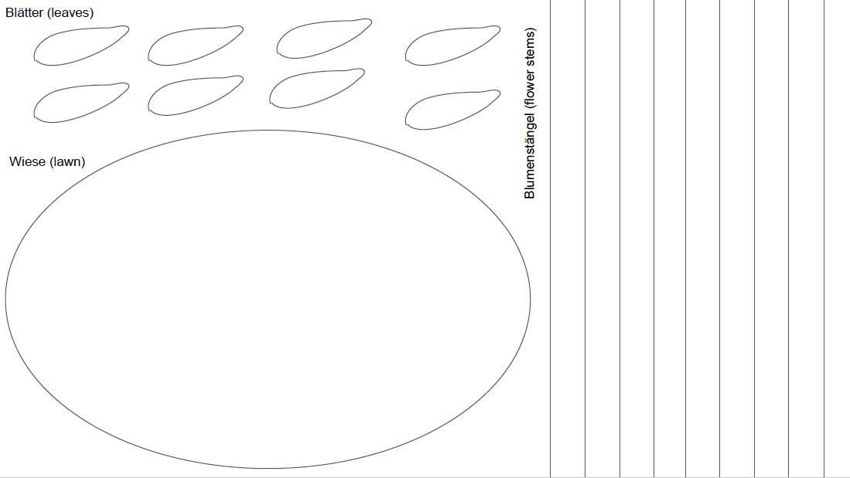

Folding your stems (using your two strips of green paper):
